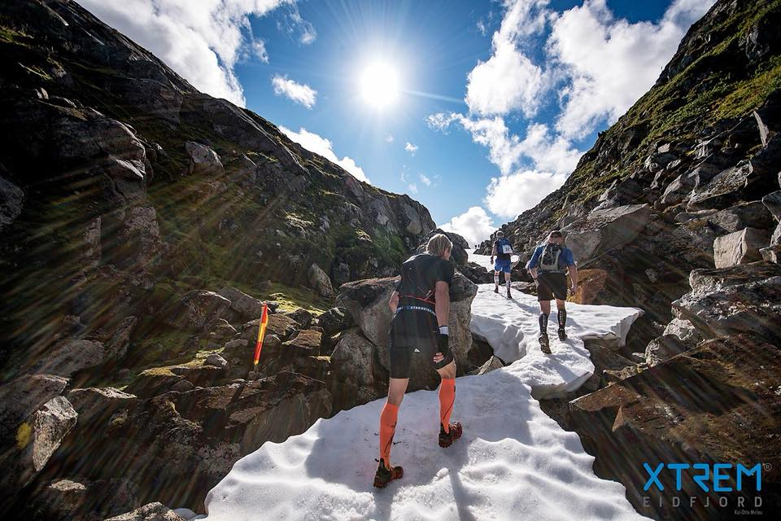

RACE MANUAL 2019
All participants must read and understand this document before entering the start for Dynafit Hardangervidda Marathon

Table of content
1. FEES 3
Participation fees include: 3
2. CONDITIONS FOR WITHDRAWAL 3
3. REGISTRATION 3
Minimum requirements for equipment for any weather conditions, both half marathon and full marathon: 3
4. START 4
Marathon 4
Half-Marathon 4
5. TRAIL DESCRIPTION 5
Marathon 5
HalF Marathon 5
Trail map: 6
6. CUT-OFF TIME 7
7. RULES 7
Age limit 7
Help and aid 7
General rules 7
Breaking the rules 7
8. ACCOMMODATION 8
9. AWARD CEREMONY 8

1. FEES
Participation fees for 2019 are:
- 1 – 31. May NOK 700, -
- 1. June – 15. August NOK 850, -
- 16. – 29. August NOK 1.000, -

Participation fees include:
- Participating in an amazing race in untouched nature in Hardangervidda
- Sports drinks and bananas in food stations
- Marked trail
- Reward for participation
- Electronic stop watch with tracker under the race

2. CONDITIONS FOR WITHDRAWAL

Participation fees will not be refunded, unless the participant can put forward a valid medical certificate (a certificate from physical therapy is not valid) NOK 150, - would be taken from the participation fees to cover administrative fees.

After August 1st the participation fees will not be refunded, no matter the reason. It is also not possible to transfer the fees to future races.

3. REGISTRATION

Registration will be held in Eidfjord Community hall located next to Lægreid school in Eidfjord. The registration will happen on Friday 30th of August from 6 pm to 8 pm and on Saturday 31st of August from 7 am to 9 am (Half Marathon until 10 am).

It will also be possible to have one shoe bag delivered to Simadal (10 km), where the asphalt road ends and Hjølmoberget (38 km), start of gravel road. Participants of the full Marathon may also bring a special needs bag including e.g. food, drinks, extra clothing or other things whom you would like to have at Fossatromme (22km). Shoe bags will be marked with participant number and delivered if needed under registration. Shoe bags and special needs bag shall be delivered to the marked cars parked outside Eidfjord Community hall, when you check-in, these have to be delivered at 9.30 am at latest.

Minimum requirements for equipment for any weather conditions, both half marathon and full marathon:
- A fully charged phone
- Wind and water proof jacket and pants
- Thermal underwear top

Equipment needs to be packed in a suitable ruck sack. There are no minimum requirements for weight.

Participants are allowed to use trekking poles.

4. START

Marathon
The start of the Marathon is Saturday 31st of August at 10 am on the bridge towards Simadal in Eidfjord centrum by Vik Pensjonat.

Half-Marathon
The start of the half-Marathon is Saturday 31st of August from Måbø museum in Måbødalen at 12 pm. There is bus transportation from Quality Hotel Vøringsfoss in Eidfjord centrum. The buses will leave promptly at 11:15 am, be there well in advance. There are parking spaces available at the clay court by Lægreid school/Eidfjord sports See map attached of the start/finish line area.

The first participants are estimated to reach the finish line by Norsk Natursenter in Øvre Eidfjord around 2 pm. There will be a continuous shuttle bus back to Eidfjord centrum.
Fossatromme by Vøringsfossen is the hub for the entire event. This is where participants will meet up. There are plenty of parking spaces available. There is no transport to/from Fossatromme to/from Eidfjord centrum.

Map start- and finish area:
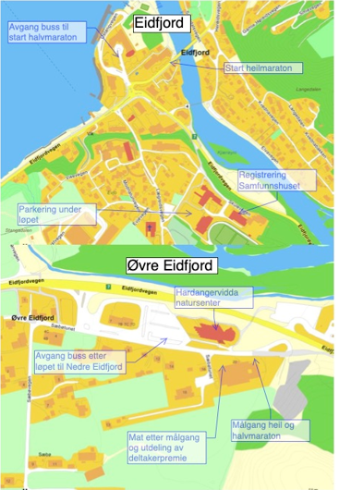

5. TRAIL DESCRIPTION

The complete distance of Dynafit Hardangervidda Marathon is 44,2 km and the half-marathon is 24,9km.

The entire trail is marked with adhesive bands.

Marathon
Hardangervidda Marathon is not one of the normal marathons where you would run along asphalt in a relative flat trail. Running on paths, crossing rivers, snow, ice and mud. Underway in the marathon you’ll pass the glacier Hardangerjøkulen and the famous waterfall Vøringsfossen, in addition to the narrow and spectacular Hjølmodalen, which one could say is one of the true diamonds in Hardanger. The participants can expect a hard, brutal and wonderful race with Hardangervidda in the background.

After 10 km, Simadal, you’ll reach the first drinking station and the possibility to change shoes. The brutal climb starts here, you will be going from 0 – 1200 in elevation within a 3 km distance. A lot of participants will feel that this is a race within the race, a brutal mountain race in the midst of a terrain race. After you reach the top, the trail turns gracefully in beautiful nature with mountains, paths and crossing of rivers before it heads down towards the passing of Vøringsfossen after 21 km. Here is another drinking station and the possibility to get your special needs bag. If you pass 21 km within 4 km you are allowed to continue the trail towards muddy paths where it is possible to enjoy beautiful nature when getting close to the next drinking station after 38 km, Hjølmoberget. It is also possible to change shoes here, before you continue the race on gravel road, down the spectacular Hjølmodalen and the remaining 4 km on asphalt road in to the finish line by Norsk Natursenter in Øvre Eidfjord.

Half Marathon
The half-marathon starts in the beautiful Måbødalen, it starts with an elevation of about 500 metres, before reaching the first drinking station after 3 km in Høel. This is where you reach the same trail as the full-marathon participants and follow until the finish line by Norsk Natursenter in Øvre Eidfjord.
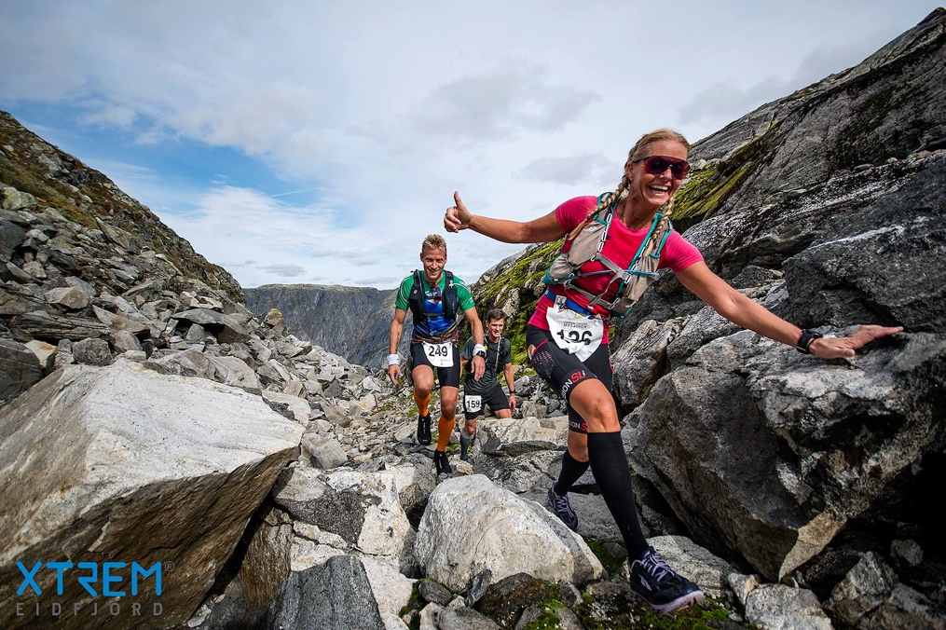
Drinking/food stations:
- After 10 km in Simadal – Winforce sports drinks and water – shoe change
- After 21 km at Fossatromme – water, Winforce sports drinks, coke, bananas, energy bars and nut mix – special needs bag
- After 38 km at Hjølmoberget – water, Winforce sports drinks, coke, bananas, energy bars and nut mix – shoe change
- During half-marathon after 3km in Høel – Winforce sports drinks and water

Trail map:
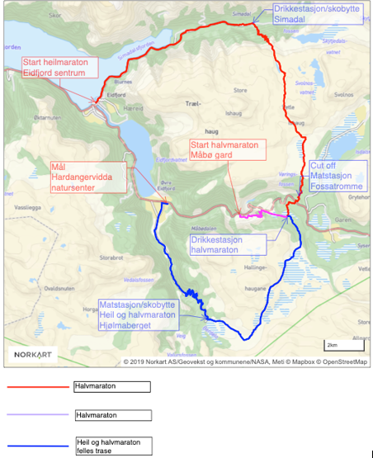

6. CUT-OFF TIME
The cut-off time is after reaching Fossatromme, 21km in 4 hours. There will be transport arranged to Norsk Natursenter from Fossatromme if you can’t reach the check point before cut-off time. There can be little to no signal in the trail and the gps may stop working properly. A heads up that the km on a gps watch may differ from the km points after 21 km and cut-off.

7. RULES

The rules are minimum requirements. It is also expected that every participant uses common sense and shows respect to the mountains. The rules could be changed due to weather conditions.

Age limit

The age limit of Dynafit Hardangervidda marathon is set to 18 years, and half-marathon is set to 16 years

Help and aid

- In emergency situations it is expected that every participant helps
- If there is to be an emergency situation, get in contact with the crew rear of participants

General rules
- You are not allowed to throw rubbish underway. please bring the rubbish to check point’s and/or to the finish line. Throwing rubbish in the nature could cause disqualification.
- The event organizer could eliminate participants from the race due to security reasons.
- Weather conditions or other security reasons could cause the event organizer to hold back participants from leaving check points. participants in Dynafit Hardangervidda Marathon must be aware that the race could be stopped at any point due to weather conditions stopping the race from continuing.
- Participants who chooses to eliminate themselves must get out of the mountains on their own, unless they are experience injuries or illness, event organizer will organise the transport.
- Participants who choose to eliminate themselves must let the crew at drinking/food stations know, or directly on phone to race organizers

Breaking the rules

Punishment/elimination can be given by breaking the rules, unsportly behaviour or if a participant puts them self or others in unnecessary risk. Punishments could be given by event organizer, adding time or even cause disqualification.

8. ACCOMMODATION

Please contact accommodation in Eidfjord for booking accommodation under Dynafit Hardangervidda Marathon. It is recommended to book early as the race is in the midst of tourism peak-season in Eidfjord. There is an overview of accommodation on www.visiteidfjord.no.

9. AWARD CEREMONY

Every participant who finishes the race will receive a shirt delivered by Dynafit. This will be given after reaching the finish line by Norsk Natursenter. There will also be given out a delicious meat soup to all the participants.

